Set up Angular Project (homework) with Wampserver.

01. Install Wampserver (https://sourceforge.net/projects/wampserver/)

02. Copy project to C:\wamp64\www\

03. Start Wampserver, click mouse left choose "PHPMyAdmin" and login with username "Root" and Passwork blank

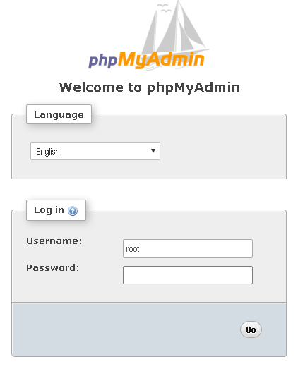

04. In PHPMyAdmin page, select tab database, create database, input name "online_shop" and collation "utf8mb4_unicode_ci" and click button "create".

05. click into online_shop page, select "import"

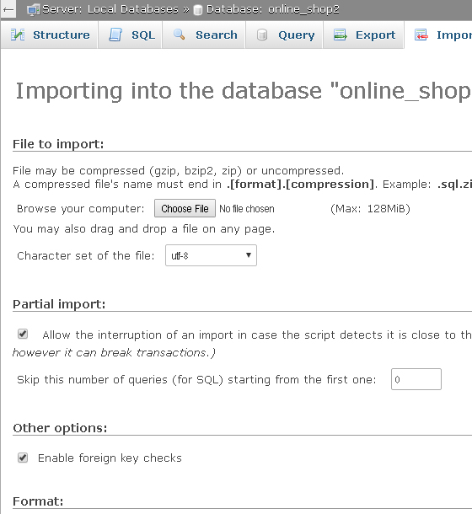

06. Select file SQL "shop_ban_hang.sql" in project to upload and click "Go" button.

07. Click mouse left to icon wampserver, select "Restart all services".

08. Create file .htaccess with Notepad and input

RewriteEngine On

# If an existing asset or directory is requested go to it as it is

RewriteCond %{DOCUMENT_ROOT}%{REQUEST_URI} -f [OR]

RewriteCond %{DOCUMENT_ROOT}%{REQUEST_URI} -d

RewriteRule ^ - [L]

# If the requested resource doesn't exist, use index.html

RewriteRule ^ /angular_project/index.html

then Save and Close.

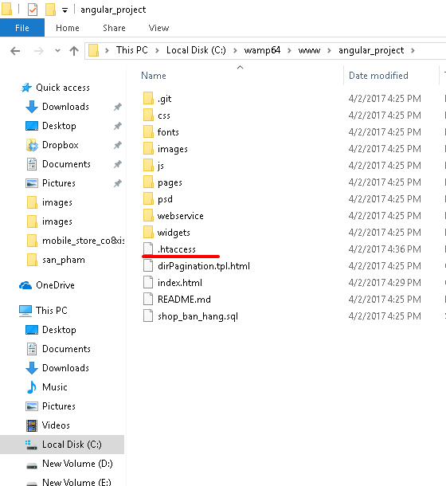

08. Open Chrome browser and paste link "http://localhost/angular_project/"

Then result:



and Mobile

